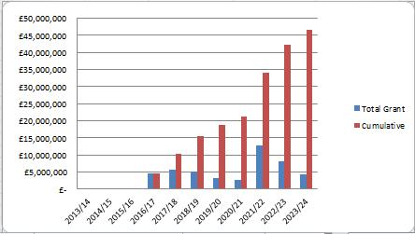

|  |  |  |  |  |
| --- | --- | --- | --- | --- |
|  | **Quarter 1 (Apr – June 19)** | **Quarter 2 (Jul-Sept 19)** | **In Year Actual** | **BDP Forecast for Year** |
| **Grant** | £0 | £0 | £0 | £2,000,000 |
| **Loan** | £0 | £0 | £0 | £3,587,214 |
| **Housing Completions** | 33 | 57 | 90 | 252 |

To date, £15,605,975 has been paid to LCC as grant, with a further £10m contractually committed to be paid upon receipt of annual payments on completed disposals. No payments were made during Q2 2019/20.

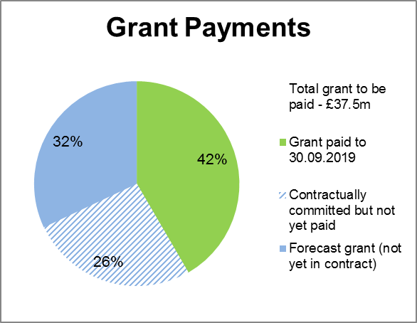

There have been 630 housing completions to date on Homes England City Deal sites. There were 57 housing completions during this reporting period.

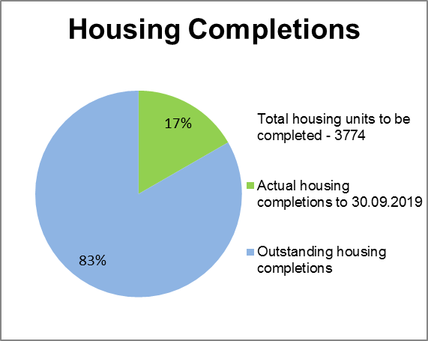

Housing starts have been claimed for 1,657 units on Homes England City Deal sites to date. During this reporting period no new starts on site were recorded. Starts are claimed in full upon commencement of the site.

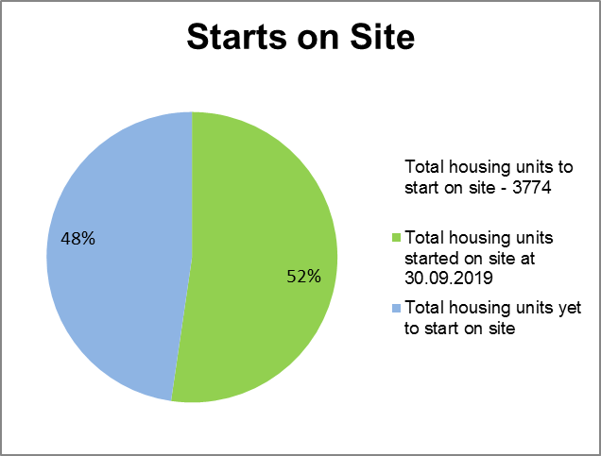

Of the Homes England residential City Deal sites, only Pickerings Farm is yet to achieve planning. Due to a recent Masterplanning exercise the Outline Planning Application will total 345 units (on Homes England land). An amended planning consent for the remaining Whittingham phases is required which has recently been submitted but this uplift is not reflected above.

